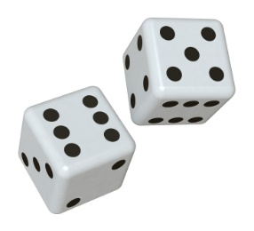
What can you learn from probability Games? http://www.btwaters.com/probab/probab.html
Name(s) max 2: __________________________________________

GAME | PROBLEM | ANALYSIS | WHAT YOU LEARNED FROM PLAYING YOURSELF? | COMPARE THEORETICAL TO EXPERIMENTAL PROBABILITY FOR SMALL NUMBER OF TRIALS VS LARGE  *check probability results report | WHAT IDEAS DO YOU HAVE FOR YOUR OWN CARNIVAL GAME CREATION USING PROBABILITY?
Coin Flip
Dice Roll
Key Problem
Monty Hall Puzzle
Coin Game

